**AWS DYNAMODB**

🡺Open dynamodb service

🡺Create a table

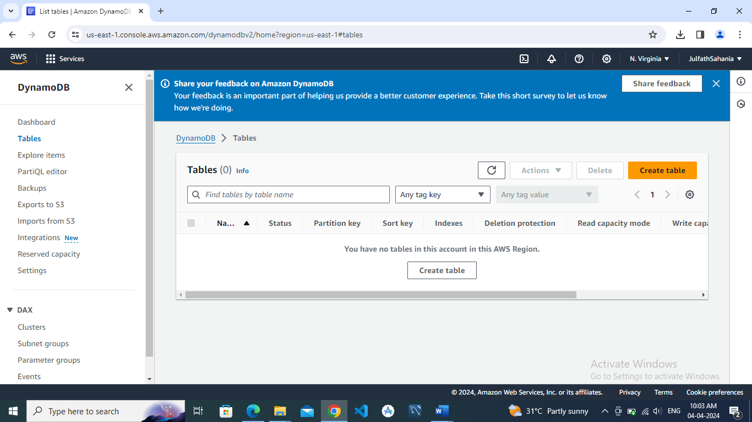

🡺Add items to the table

